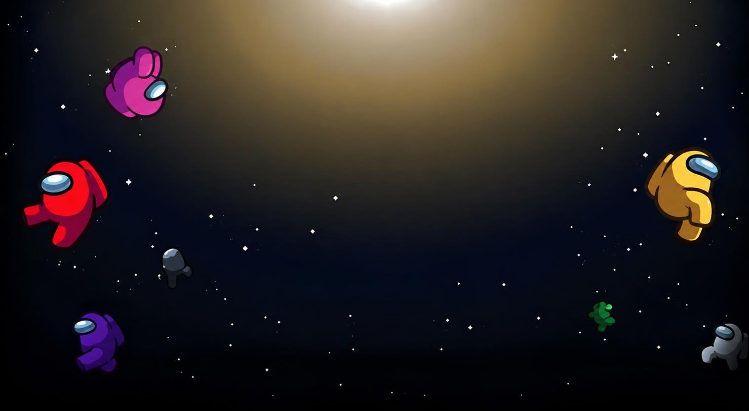

ACCelerate’26
TANUSHKA RATHORE











OUR IDEA & INTEGRATION

THE TASK THE VENTS THE FIX

Create a precise AI prompt that generates a professional lost item report poster with a highlighted item . contact details , item branding colour etc.
Using Adobe Firefly and Prompt Engineering, we combine user details, university branding, layout instructions, and design constraints to generate a professional poster automatically.

Our structured prompt uses roles, constraints, and visual hierarchy to create clear, consistent, and professional posters that attract attention and improve the chances of recovering lost items
.




Prompt & Techstack

Role: Expert Graphic Designer
Create a mobile-friendly Lost Item Report poster for Amity University Madhya Pradesh. Use a professional corporate style with nude and brick-inspired colors. Highlight a grey Dell laptop at the center (40% focus area). Include item details (Laptop, Dell, Grey, Lost on 30 May at E Block Foyer) and contact information (Tanushka Rathore, 887111***, tanushkarathore@gmail.com). Maintain university branding, strong visual hierarchy, clean typography, and a high-resolution portrait layout (1080×1920).
Tech Stack:
- Adobe Firefly
- Prompt Engineering
- Role Prompting
- Constraint-Based Prompting
- Mobile-First Design




THE OUTPUT

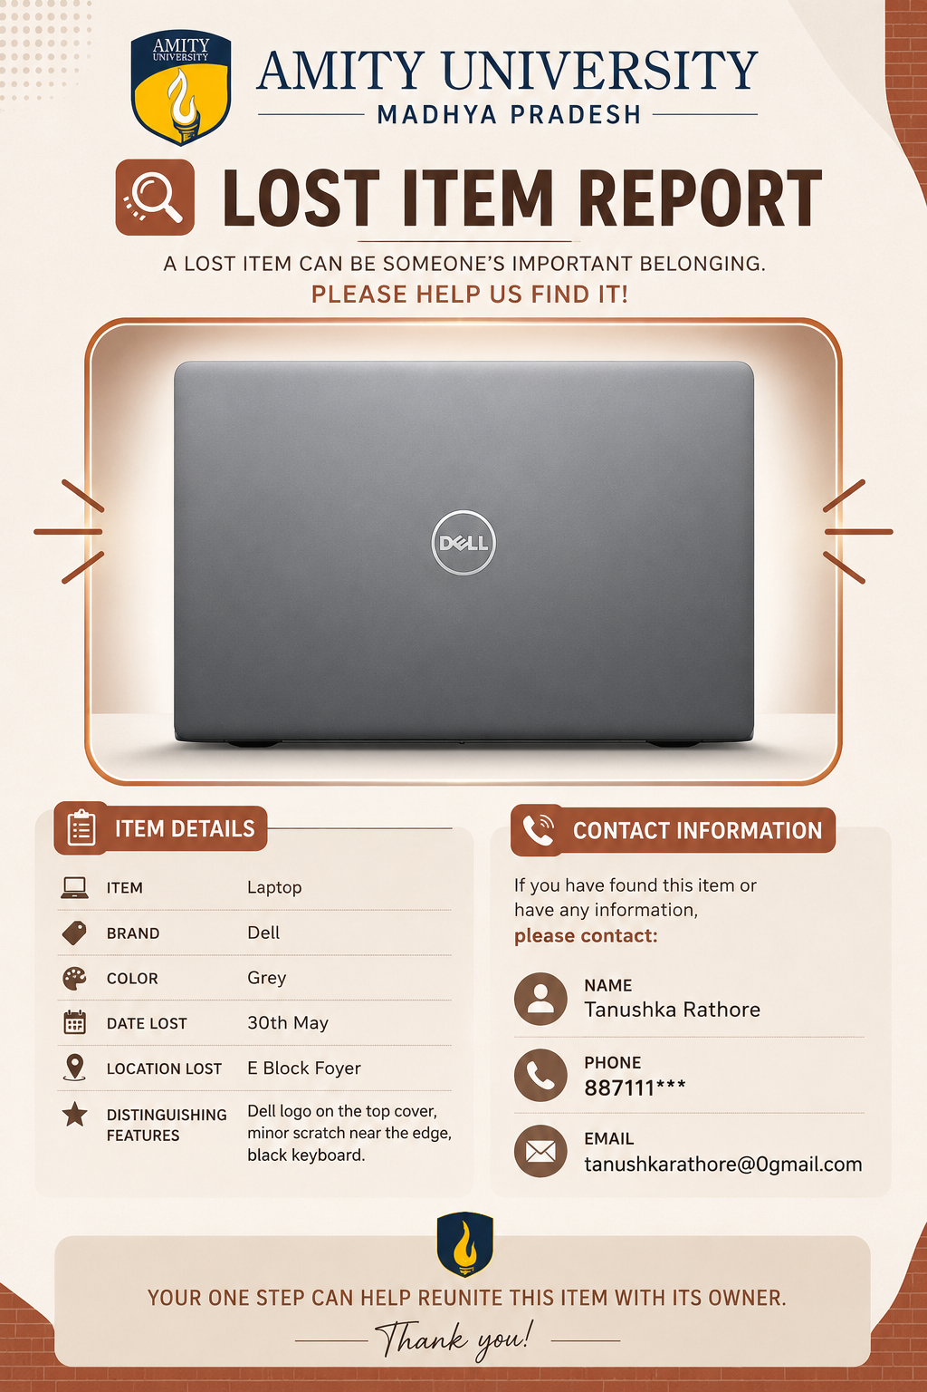

PROJECT RESULTS

Functionality:

Generates a professional lost item report poster

With a highlighted item image item details,

Contact information ,university branding and a

Mobile friendly layout.

Tech Stack:

Adobe firefly, prompt engineering ,role prompting ,

Constraint based prompting ,mobile first design

Principle.

Output:

A high-resolution corporate – poster optimized for

Digital notice boards , WhatsAPP sharing and

Smart phone viewing .

✅ Functionality: k




TASK COMPLETED!
Thank you for reviewing our project submission.

